Author’s First Name SURNAME

The Title in English, in Small Caps

Title in Russian

Аннотация (in Russian)
Maximum 2,000 characters. Font size: 10 pt, justified alignment, single spacing.
Ключевые слова (in Russian): 3–5 items; separated by semicolons; italicized

The total length of the manuscript must not exceed 35,000 characters, including spaces.

Page margins: 5 cm at the top and bottom, 4 cm on the left and right. Font: Times New Roman, font size: 11 pt, justified alignment, single spacing.

References in the text should be indicated in square brackets. They must contain the author’s surname in small caps, as well as the year of publication and the page number, for example: [Austin 1971: 66]. In the case of two authors, the surnames should be connected by a hyphen [BorkovskiJ–Kuznetsov 1963: 66–85]; if there are more than two authors, only the first author should be indicated, followed by et al. [Notten et al. 2013: 66], or in Russian и др. [Рубинштейн и др. 1998: 226].

Footnotes should be numbered consecutively and placed at the bottom of the page.

As an optional element, articles published in the journal may include illustrations, photographs, and tables. Please place figure captions below the figures and table titles above the tables. It is also possible to add appendices or supplementary materials after the bibliography and before the author affiliation.

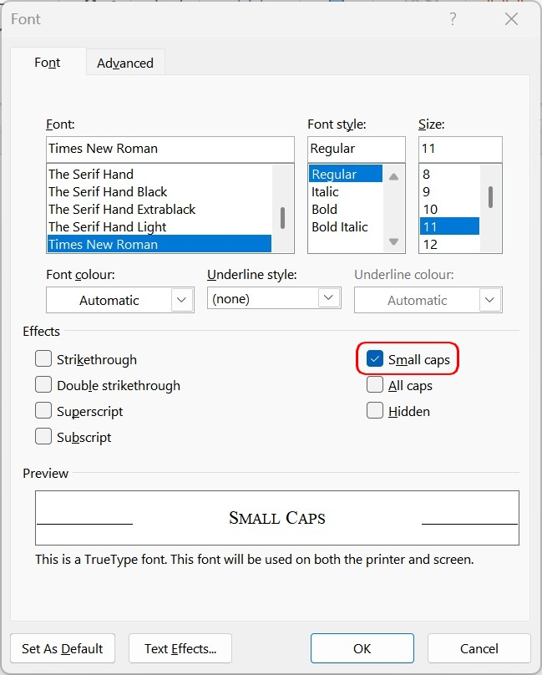
Figure 1. Use of Small Capitals

The bibliography, arranged in alphabetical order, must be provided in both Latin and Cyrillic scripts. Transliteration into Cyrillic should follow the ISO 9 standard; see: https://en.wikipedia.org/wiki/ISO_9.
Only works that have actually been used and cited in the manuscript should be included in the bibliography. All references cited in the text must be fully listed in the bibliography. Font size: 10 pt.

References
Austin 1971: Austin, John L., How to do things with words. London: Oxford University Press.
Bjørnflaten 2006: Bjørnflaten, Jan I., Chronologies of the Slavicization of Northern Russia mirrored by Slavic loanwords in Finnic and Baltic // Nuorluoto, Juhani (ed.), The Slavicization of the Russian North. Slavica Helsingiensia 27. 50–77.
Hentschel–Kittel 2014: Hentschel, Gerd, Kittel, Bernhard, Zu Sprachkompetenzen und Sprachverhalten von jungen Weißrussen und Ukrainern in Weißrussland und der Ukraine (und zu Schwierigkeiten eines solchen Vergleichs auf der Basis unterschiedlicher Erhebungen) // Wiener Slavistisches Jahrbuch 2. 98–128.
Kuznecova 2019: Kuznecova, Irina V., Orientalizmy-antroponimy v ûžnoslavânskih ustojčivyh sravneniâh // Studia Slavica 64. https://doi.org/10.1556/060.2019.64107 (Data obraŝeniâ: 12.08.2019).
Taranovskij 2000: Taranovskij, Kirill F., O poèzii i poètike. Moskva: Âzyki russkoj kul’tury.
Žuravlev–Oŝepkova 2020: Žuravlev, Ignatij V., Oŝepkova, Ekaterina S., Mozg i âzyk: problema literalizacii // Soznanie. Âzyk. Mozg. Kollektivnaâ monografiâ. Pod red. Evgeniâ F. Tarasova, Ignatiâ V. Žuravleva. Moskva, Institut âzykoznaniâ RAN. 26–45.

Литература
Журавлев–Ощепкова 2020: Журавлев, Игнатий В., Ощепкова, Екатерина С., Мозг и язык: проблема литерализации // Сознание. Язык. Мозг. Коллективная монография. Под ред. Евгения Ф. Тарасовa, Игнатия В. Журавлевa. Москва, Институт языкознания РАН. 26–45.
Кузнецова 2019: Кузнецова, Ирина В., Ориентализмы-антропонимы в южнославянских устойчивых сравнениях // Studia Slavica 64. https://doi.org/10.1556/060.2019.64107 (Дата обращения: 12.08.2019).
Тарановский 2000: Тарановский, Кирилл Ф., О поэзии и поэтике. Москва: Языки русской культуры.
Austin 1971: Austin, John L., How to do things with words. London: Oxford University Press.
Bjørnflaten 2006: Bjørnflaten, Jan I., Chronologies of the Slavicization of Northern Russia mirrored by Slavic loanwords in Finnic and Baltic // Nuorluoto, Juhani (ed.), The Slavicization of the Russian North. Slavica Helsingiensia 27. 50–77.
Hentschel–Kittel 2014: Hentschel, Gerd, Kittel, Bernhard, Zu Sprachkompetenzen und Sprachverhalten von jungen Weißrussen und Ukrainern in Weißrussland und der Ukraine (und zu Schwierigkeiten eines solchen Vergleichs auf der Basis unterschiedlicher Erhebungen) // Wiener Slavistisches Jahrbuch 2. 98–128.

Upon submission of the manuscript, the author must place one of the following two statements after the bibliography:

Statement on the Use of AI
1. During the preparation of this study, I used an artificial intelligence-based tool (type: ……) for the preparation of the following section(s): (……). The content generated by the tool was reviewed and, where necessary, revised by me, and I take full responsibility for the final manuscript.

2. I declare that no artificial intelligence-based tool was used in the preparation of this study.

The final element of the manuscript should be the author's affiliation in English:

First Name Surname
Institution / Affiliation
City, Country
Institutional e-mail address
ORCID iD

***

Checklist for Reviewing the Structural Elements of the Manuscript:

- Author(s)’ name(s)
- Title
- Abstract
- Keywords
- Main text of the manuscript
- Bibliography
- AI statement
- Affiliation

Before submitting your article for review, please remove any personal metadata from the document as follows:
Right-click the file → Properties → Details → Remove Properties and Personal Information → Select the properties to remove from this file → OK.

For submissions to the Scientific Review section, the main title should refer to the subject matter of the work under review, while the subtitle should contain the bibliographic description of the work (the author or editor of the book, title, place of publication, publisher, year of publication, length of the book, and ISBN number).
Font size: 9 pt
To apply small capitals:select the text → right-click → Font → check Small Caps (or use the keyboard shortcut Ctrl + Shift + K).

