Title
Firstname Lastname¹ – Firstname Lastname² – Firstname Lastname^{2,*}
¹Affiliation 1
²Affiliation 2
*Correspondence: e-mail@e-mail.com
SUMMARY
A single paragraph of about 200 words maximum. For research articles, abstracts should give a pertinent overview of the work. We strongly recommend to use the following style of structured abstracts, but without headings: (1) Background: Place the question addressed in a broad context and highlight the purpose of the study; (2) Methods: Describe briefly the main methods or treatments applied; (3) Results: Summarize the article's main findings; and (4) Conclusions: Indicate the main conclusions or interpretations. The abstract should be an objective representation of the article.
Keywords: keyword 1; keyword 2; keyword 3 (List three to five keywords specific to the article)

How to Use This Template
The template details the sections that can be used in a manuscript. Note that each section has a corresponding style, which can be found in the ‘Styles’ menu of Word. Sections that are not mandatory are listed as such. The section titles given are for Articles. Review papers have a more flexible structure.
Remove this paragraph before you type your text. For any questions, please contact the editorial office of the journal.

INTRODUCTION

The introduction should briefly place the study in a broad context and highlight why it is important. It should define the purpose of the work and its significance. The current state of the research field should be reviewed carefully and key publications cited. Please highlight controversial and diverging hypotheses when necessary. Finally, briefly mention the main aim of the work and highlight the principal conclusions. As far as possible, please keep the introduction comprehensible to scientists outside your particular field of research. Cite references in the text by name and year in parentheses, for examples (Pepó, 1990), or Bocz and Nagy (1981) or (Abbott, 1991; Barakat et al., 1995a, b; Kelso and Smith, 1998; Medvec et al., 1999, 2000).

MATERIALS AND METHODS

Materials and Methods should be described with sufficient details to allow others to replicate and build on published results. New methods and protocols should be described in detail while well-established methods can be briefly described and appropriately cited.
The main purposes are to describe, and sometimes defend, the experimental design and to provide sufficient detail so that a competent worker can repeat the study. Describes what kind(s) of research methods were used and how the study was constructed or implemented.

RESULTS AND DISCUSSION

This part of work collates and summarizes the data collected and calculates totals or trends, statistically significant findings, etc., should be concise and clear.
This section may be divided by subheadings. It should provide a concise and precise description of the experimental results, their interpretation as well as the experimental conclusions that can be drawn.
Authors should discuss the results and how they can be interpreted in perspective of previous studies and of the working hypotheses. The findings and their implications should be discussed in the broadest context possible. Future research directions may also be highlighted.

CONCLUSIONS

Author(s) discusses applications or implications of the results.
Formal requirements
Tables
The tables should be black and white coloured;
Use Times New Roman, 8 pt.;
Tables captions above the tables: tables should be marked by Arabic numbers in italic font style followed by the name/description of the table with normal font style.
Additional information about the table (e.g. legend etc.) can be added under the table

Figures
The figures should be black and white coloured with clear visibility.
Figures should be marked by Arabic number in italic font style followed by the description with normal font style under the figures;

Figures, Tables and Schemes
All figures and tables should be cited in the main text as Figure 1, or (Table 5).
BE ATTENTION THE NUMBER OF FIGURES AND NUMBER OF TABLE SHOULD NOT EXCEED MAX. 4-4.

Figure 1. This is a figure, Schemes follow the same formatting

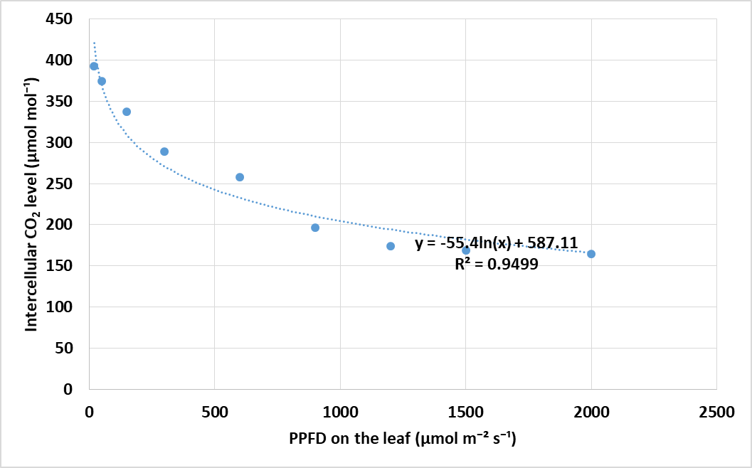
If there are multiple panels, they should be listed as: (a) Description of what is contained in the first panel; (b) Description of what is contained in the second panel. Figures should be placed in the main text near to the first time they are cited. A caption on a single line should be centered.

Table 1. Title of the table. Tables should be placed in the main text near to the first time they are cited

Title 1 | Title 2 | Title 3
entry 1 | data | data
entry 2 | data | data ¹
¹ Tables may have a footer, if it was indicated.

Formatting of Mathematical formulas
Equation example:
a+b = 25, | (1)
equations should be numbered, the text following an equation need not be a new paragraph. Please punctuate equations as regular text.
Nomenclature

Both the accepted common name and the chemical name of pesticides must be given upon first mention in the manuscript. Use chemical symbols for elements, ions, and simple compounds except at the beginning of a sentence or in a title or heading. The Latin binomial or trinomial (name in Italic) must be included with the common name for all plants, insects, pathogens, and animals at first mention.

Units and measurements
For units use international system of units (SI) deriver or arbitrary units.
An exponent attached to a symbol containing a prefix indicates that the unit with its prefix is raised to the power expressed by the exponent.
Use a space to show multiplication of units and a negative exponent to show division: these are strongly preferred to the otherwise acceptable center dot (•) and solidus (/). Thus, m s⁻¹ is preferred to m/s. Only one solidus may be used in combinations of units, unless paretheses are used to avoid ambiguity. Thus μmol/(m² s) is acceptable, but μmol/m2/s is not allowed. Where the denominator unit is modified by a quantity, the negative exponent goes after the unit, not the number. Example: g 1000 seed⁻¹.
ACKNOWLEDMENTS
Please add: “This research was funded by NAME OF FUNDER, grant number XXX” and “The APC was funded by XXX”. Check carefully that the details given are accurate.

REFERENCES
The list of references should only include works that are cited in the text and that have been published or accepted for publication. Personal communications and unpublished works should only be mentioned in the text. Do not use footnotes or endnotes as a substitute for a reference list.
Reference list entries should be alphabetized by the last names of the first author of each work. Order multi-author publications of the same first author alphabetically with respect to second, third, etc. author. Publications of exactly the same author(s) must be ordered chronologically.

WHERE AVAILABLE, URLS AND DOIS FOR THE REFERENCES HAVE BEEN PROVIDED.

Author 1, A.B.; Author 2, C.D. (Year): Title of the article. Abbreviated Journal Name, Volume, DOI number, page range.
Author 1, A.; Author 2, B. (Year): Title of the chapter. In Book Title, 2nd ed.; Editor 1, A., Editor 2, B., Eds.; Publisher: Publisher Location, Country, Volume 3, pp. 154–196.
Author 1, A.; Author 2, B. (Year): Book Title, 3rd ed.; Publisher: Publisher Location, Country, pp. 154–196.
Author 1, A.B.; Author 2, C.: Title of Unpublished Work. Abbreviated Journal Name stage of publication (under review; accepted; in press) DOI number.
Author 1, A.B. (Year): (University, City, State, Country); Author 2, C. (Institute, City, State, Country). Personal communication.
Author 1, A.B.; Author 2, C.D.; Author 3, E.F. (Year): Title of Presentation. In Title of the Collected Work (if available), Proceedings of the Name of the Conference, Location of Conference, Country, Date of Conference; Editor 1, Editor 2, Eds. (if available); Publisher: City, Country, Abstract Number (optional), DOI number, Pagination (optional).
Author 1, A.B. (Year): Title of Thesis. Level of Thesis, Degree-Granting University, Location of University, Date of Completion.
Title of Site. Available online: URL, DOI number (accessed on Day Month Year).

