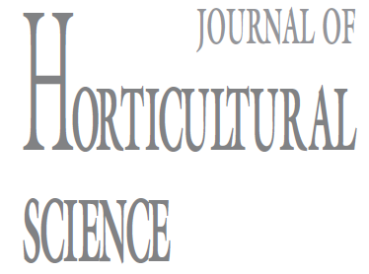

AUTHORʹS DECLARATION

Manuscript title:

Full names of all authors (in order to appear on manuscript):

1.
2.
3.

In order to publish your manuscript in the International Journal of Horticultural Science (University of Debrecen) it is necessary that this form should be signed by the first author of the manuscript and uploaded with the submitted article on the website of the Journal.

Your signature affirms that:
- the results (or any part of them) used in the manuscript have not been sent for publication to any other journal nor have they already been published
- no results of other researches were used in the submitted manuscript without proper citation
- all co-authors agree to the posting of the full text of this manuscript on the web page of the journal and to the inclusion of references in databases accessible on the internet in accordance of the Creative Common’s License 4.0 CC BY
- all co-authors were actively involved in obtaining results
- all co-authors agree to publication of the manuscript even after peer review amendments
- the authors dispose on all necessary research permissions if the research were carried out in sites protected by national or international law and agreements in nature conservation
- the authors alone are responsible for the content and writing of the paper
- the article shall be delivered to the Publisher free of copyright charges. In the event that the article is not accepted and published by Publisher, this agreement becomes null and void

All authors agree that editorial correspondence will be sent to:

Name:
Address:
E-mail:
Telephone:
Date:
Date: Signature of the first author: …………………………………………

Manuscripts will not be received without the signed declaration of the corresponding author!

